Preparing for a Parliamentary Style Debate
- Choose a structure for debate from option 1 or 2.
Option 1
Use the existing debates included in Student Debate Resources that includes several scripted roles. Students with an unscripted role may choose to take on the role of a backbencher or sit on the cross bench. They may contribute to the debate with their own scripted speech or a spontaneous speech.
Option 2
Students write their own debates on to the Debate Template provided as a word document.
- Print Facilitator Running Sheet
- Photocopy individual debate scripts onto coloured paper. Colour coding is shown as a footnote on each script. This supports students to identify each role and recognise the Government, Opposition Parties and Independents. It highlights that the Government must have more members on their side, as you form Government by having a majority in the House of Assembly.
- Photocopy Debate Name Tags relevant for the roles in your debate onto coloured card using the template provided. Colour coding is shown as a footnote on each name tag.
- Photocopy an A3 copy of The House of Assembly Map to show how to set up the learning area for the debate.
- Photocopy the Bill for each participant.
- Organise selection of roles for the debate including a Facilitator to direct proceedings. You may choose to be the Facilitator or support a student to take on this role.
- Organise props that are needed for the debate including a bell and mace (eg broom handle).
- Discuss ways that participants can support their Party Member after they have spoken, using a range of phrases such as ‘Hear, hear!’, ‘Good point!’ or ‘I agree!’
Students rehearse scripts before participating in the debate as a whole group.

NEXT Page

Student Parliamentary Debate Program
Young people visit Parliament House to engage with the spirit of South Australia's government and experience the reality of the parliamentary decision making process.
The annual Parliament House Education Service "Open House" is an opportunity for youth from all over the State to learn about the importance of democracy in South Australia. Classes of students come into Parliament House to have a hands-on experience of the democratic process, under the same rules and procedures that our State's politicians use.
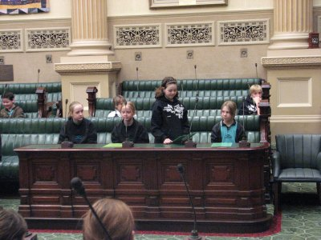
Every year students have the opportunity to role-play Parliamentarians and Parliamentary Officers in a one hour debate, developing their knowledge about the implications of democracy, the South Australian political system, the parliamentary law-making process, and the need to work collaboratively to allow shared decision making by a group.
A range of students have attended from metropolitan and rural, private and public, primary and high-schools. Students are prepared for the event by their teachers in the weeks before, learning about the South Australian parliamentary process and brainstorming the arguments for and against the topic to be debated.
With students taking the roles of Speaker, Serjeant-at-Arms, Premier and Leader of the Opposition, as well as Ministers and Members of Parliament, classes debated the merits of several bills under parliamentary conditions. Topics for debate included:
- The Lengthening of the School Day Bill
- Compulsory Issue of Mobile Phones for all School Students Bill
- Compulsory School Uniform on Excursions Bill
- OR WRITE YOUR OWN BILL USING A TEMPLATE
After the scripted section of the role-plays were completed, students were free to comment on any aspects of the proposed bill, and raise any issues they thought relevant to the issue. The young people present demonstrated a wide range of intelligent and thoughtful commentary, as topics were explored from every angle, and all implications considered.
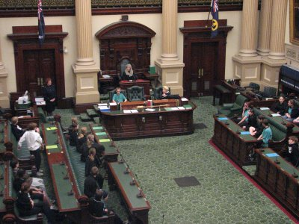
Finally, each bill was put to the vote, with each student free to make a "conscience" vote, rather than being bound by "party political" constraints. The results obtained varied widely across schools, with some bills being passed by only a narrow margin.
Judging by the vigorous debate and their reluctance to leave the Parliamentary Chambers, all the students who attended enjoyed the experience greatly; perhaps some will return in years to come as actual Members of Parliament.
Next Page

Youth Involvement in Parliament
The Parliamentary democracy in South Australia relies on informed and educated citizens to function effectively. The Parliament of SA is committed to contributing to the political education of all South Australians, especially the State's young people. To this end it sponsors two programs fostering youth involvement in politics: the Student Parliamentary Debates program, and the SA Youth Parliament Program. Youth involvement in and understanding of politics is critical to the political future of our State.
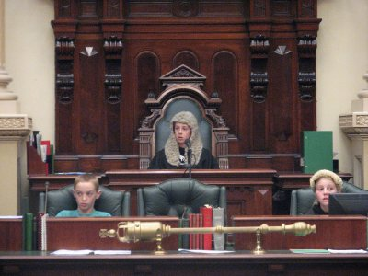
Students in action in the Student Parliamentary Debate Programme

NEXT Page – Glossary

Glossary of terms
Act: A Law made by Parliament
Amend: Changing the words in a Bill
Bill: A proposal for a Law
Campaigning: Getting support for yourself, your ideas or the group you represent
Class Structure: A ranking of people according to their position in society
Coalition: The joining of two or more political parties
Compulsory: Something that has to be done
Conservative Parties: Political Parties who support existing values and institutions and resist change
Democracy: System of Government where people have a say on who governs them
Educating: Teaching and Learning
Electorate: Geographic area of a certain number of people that a Member of Parliament represents or all of the people who live in an area represented by a Member of Parliament
Electoral Roll: The official list of eligible persons who may vote in an election
Governed: Controlled or ruled
Government: The political party with the most elected Members in Parliament
Issues: Topics for debate
Marginal Seats: An electorate that could be won by a small change in voting pattern
Policies: The principles a Political Party follows
Political Party: An organised group of people seeking political power at elections
Polling Booth: A place where people can vote in an election
Portfolio: A Minister's area of responsibility as a member of Cabinet
Question without Notice: Question asked orally of a Minister where the Minister usually has no warning of the content of the question.
Representative Democracy: System of Government where people have a say who governs them through the right to vote
Responsibility: Duty to do something
Responsible Government: The Government is responsible to the Parliament and this can be seen particularly in Question Time and the Parliament is responsible to the people and held responsible at election time
Safe Seat: An electorate where sitting Member of Parliament has far more support than the opposition
Voter: Someone entitled and enrolled to vote in elections
Westminster System: Name given to the system of Government that comes from England

